**Text Truncate widget**

**Manual Installation**

1. Copy **com.temenos.widgets.text.truncate** folder in your widgets folder (Ex: /{your project/templates/widgets/ }). Do not overwrite the **widgets.xml** from {**your project**} folder with the one provided in the widget folder.
2. Restart IDE.

**Auto-Installation**

1. Run IDE.
2. Go into the **Tools menu** -> **Options**, **Auto-install** tab and set the **Download Location** to the folder where you want to copy the widget.
3. Make sure the “**Switch Monitor on/off**” is checked.
4. Download/ Copy the widget (**com.temenos.widgets.text.truncate.zip**) to monitored folder (make sure to remove the **sample** folder from the **.zip** file).

No need to restart IDE.

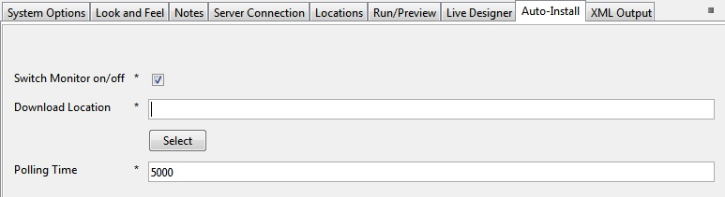

**Overview**

The **Text Truncate** widget allows the user to truncate all the text items in a section widget by a given value of characters appending a “…See more” button at the end of the truncated text, to display the full text.

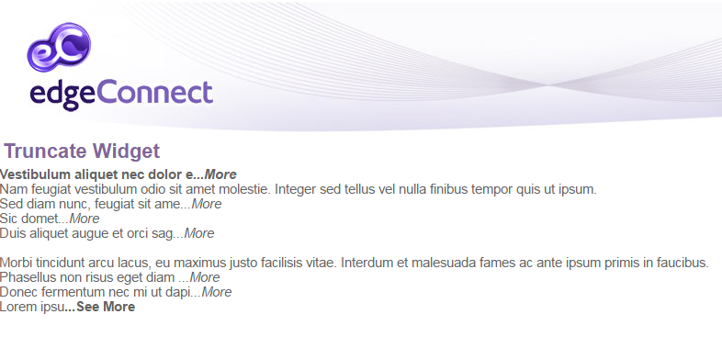

**Requirements**

For the widget to work you must have:

* EdgeConnect 6.0;
* Javascript enabled on your browser.

**Setup**

1. Add a Section in the **Presentation Editor**;

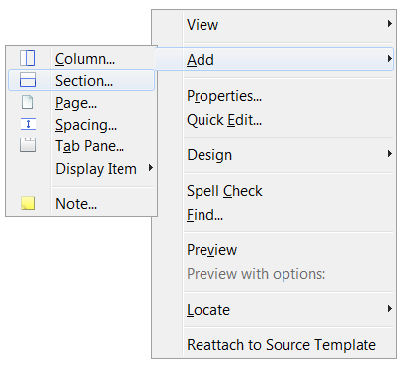

1. Add a **Display Item** > **Text**:

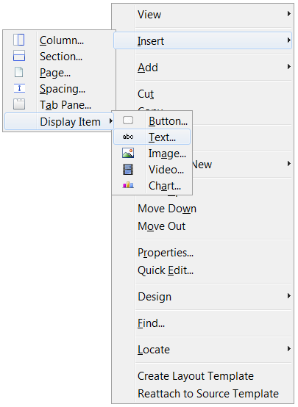

1. Double-click on the previous created section and in her **Widget Details** tab, edit the **Text Truncate** widget options.

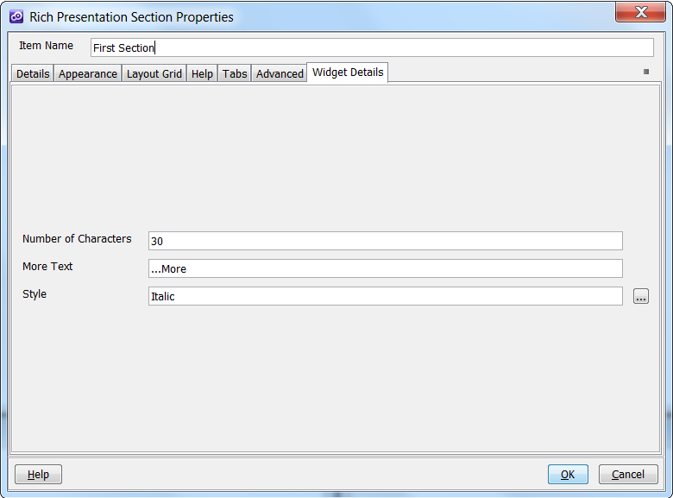

* **Number of Characters**: number of characters shown until the “…More” button;
* **More Text**: text for the “…More” button;
* **Style**: select the style for the “…More” button;